2015 MEMBERSHIP APPLICATION

I hereby apply for 2015 membership of
The Accompanists’ Guild of S.A. Inc

(Circle one category)

Ordinary Member $70

Student $20

Concession/Associate/Country $40

Life Member $700
Cheque/money order payable to:
Accompanists’ Guild of SA Inc
Direct Deposit BSB 105 148
Account 554 159 740 (notify Convenor)

Name

Address

P/C

Email

Phone (H)

(M)

(W)

Please return with Application Form to:
Geoffrey Parsons Award Convenor
Frances Wood
4 Raldon Grove
MYRTLE BANK, SA 5064
fdwood@adam.com.au
0410 512 414

REGULATIONS

- The Competitor must be a Member of the Guild. (See Membership Application)
- First Prize $5000
- Second Prize $1500
- Third Prize $1000
- The judges’ decision is final and no correspondence shall be entered into with any entrant or with any other person.
- The Judges reserve the right not to award any prize. Such a decision will be final.
- AGSA shall have the right to withhold payment of any royalty or fee to any entrant.
- AGSA shall reserve the right to record, televise, photograph, film or tape any entrant’s performance in all stages of the competition.
- The Council of the Guild shall decide the order of performance. The competition is open to pianists with professional aspirations who must be 35 years or under on the date of the final.
- Original music must be sighted and appropriate copyright rules must be followed.
- A statutory declaration or photocopy of driver’s licence indicating a minimum of two years of Australian residency is required.
- The competitors are responsible for providing their own singers and/or instrumentalists and page turners where necessary. The Guild will provide the soloist for the set work.
- Previous winners may enter the Award again, once only and not in the year following their win.

Applications should reach AGSA by
Friday 12th June2015

AGSA reserves the right to alter dates, venues or personnel as necessary
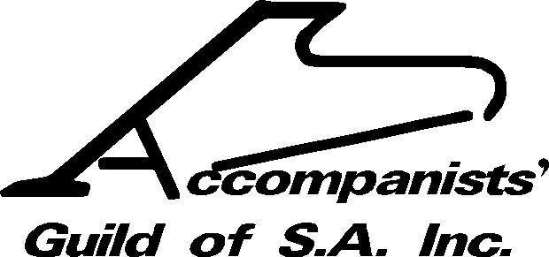

in association with
The Elder Conservatorium of Music
The University of Adelaide

2015
GEOFFREY PARSONS AWARD
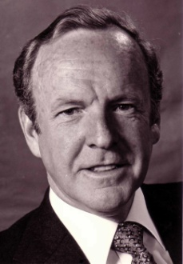
$7500

1st $5000, 2nd $1500, 3rd $1000

AUDITIONS
Monday & Tuesday 29th and 30th June
5.30pm, State Opera Studio Netley
Jury: Timothy Sexton, Monika Laczofy,
Patrick Power

FINAL
Sunday 5th July at 7pm
State Opera Studio 216 Marion Rd. Netley
Jury: Malcolm Martineau, Timothy Sexton, Monika Laczofy

Supported by
The Royal Commonwealth Society of SA
AUDITIONS

Auditions take place on Monday/Tuesday 29th & 30th June from 5.30pm in the State Opera Studio 216 Marion Road Netley. The Applicant’s Audition Program, proposed Final Program & all Performer Biographies must be presented to the Panel.

Content for Audition
1. Prepared Items (approx. 10 mins)
The competitor should present two contrasting works by different composers for piano and voice and/or instrument(s).
Guidelines for choice of works:
- suitable for recital & broadcast
- demonstrate advanced technical, ensemble and interpretative skills
- single movements are acceptable
- the majority written for keyboard
- one chamber music item beyond duo is acceptable (3 to 6 musicians)
- one orchestral reduction is acceptable

2. Set work – Rehearsal (approx.10 mins)
To briefly discuss and then perform with minimal interruption, the set work Von ewiger Liebe in C# minor by Brahms*. The competitor should carefully consider the soloist’s requirements. The set work must be included in the Final. A short rehearsal of the set work will be arranged for finalists on July 3rd or 4th with the guest soloist, tenor, Patrick Power.

* Copies of the set work are available on line or from the Convenor

3. Sight Reading (approx. 5 mins)
The competitor will have approximately two minutes to study one or two works of moderate to difficult standard, and will then accompany the Guild soloist in a reading.

NOTIFICATION OF FINALISTS

Three Finalists will be notified by phone late on Tuesday 30th June. Written details of each finalist’s program and biographies must be emailed to (Word) to cmwain@gmail.com no later than 10 am on Wednesday 1st July.

THE FINAL
Sunday July 5th at 7pm State Opera Studio
Content for Final
- 25 to 30 minutes playing time must be of professional broadcast standard
- minimum of two works by different composers, plus the set work
- may include works from the audition
- up to 10 minutes may be either chamber music or orchestral reduction

The Judges will consider
- choice of program & associate artists
- level of difficulty
- technical, ensemble and interpretative command
- general presentation
- overall impression
Previous Award Winners
1984 Bernard Depasquale 1985 Jill Bartsch
1986 Jennifer Campbell 1987 Kaye Fitton
1989 Julie Sargeant 1990 R. Robinson
1991 Michael Seifried 1992 Jamie Cock
1993 Inna Fursa 1994 Josephine Gillespie and Nerissa Pearce
1995 Esther Mae Wong 1996 Nerissa Pearce
1997 Cheryl West 1998 Leigh Harrold
1999 Alexander Hanysz 2000 Leigh Harrold
2001 Irina Lioubimova 2003 Ashley Hribar
2004 Michael Ierace 2005 Yuh T’sun Wu
2006 Anthony Hunt 2007 Amir Farid
2008 Amanda Hodder 2009 Mark Sandon
2010 Karl Geiger 2011 Szu Yu Chen
2012 Yuh T’sun Wu 2013 Tully Brookes
2014 Andrew Georg

GEOFFREY PARSONS AWARD 2015

ENTRY FORM

Name

Address

Post Code _______________________________

Email

Telephones (H)

(M)

Date of Birth

IMPORTANT – for the Audition schedule attach a list of ALL your available times between
5.30 & 7.30 pm on Mon/Tues 29/30th June

Entries Close: Friday 12th June

Please forward applications to:
AGSA, Geoffrey Parsons Award
4 Raldon Grove
MYRTLE BANK, SA 5064
Enquiries:
Convenor: 0410 512 414 fdwood@adam.com.au
Publicist: 0438 829 728 cmwain@gmail.com
www.accompanist.org.au

The Guild sincerely thanks our 2015 Sponsors

